### A Dis-Eur-France-Le Grand Pressigny-Burin-Side Design-Middle Paleolithic-Mousterian phase-ca 60,000 BP- 40,000 BP

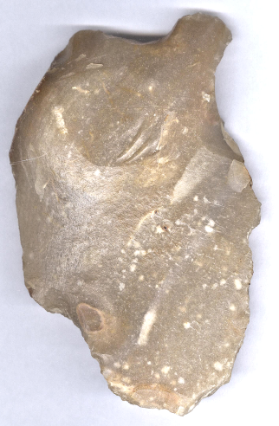 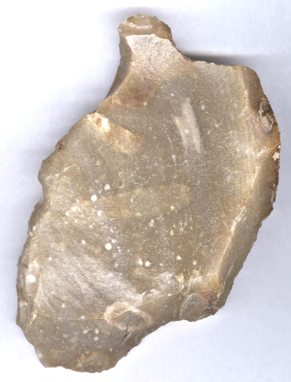

### Fig. 1. France-Le Grand Pressigny-Burin-Side Design-Middle Paleolithic-Mousterian phase-ca 60,000 BP- 40,000 BP

### **Formal Label:** France-Le Grand Pressigny-Burin-Side Design-Middle Paleolithic-Mousterian phase-ca 60,000 BP- 40,000 BP

**Display Description:** LeGrand Pressigny is the eponymous name of a flint industry known since 1863 for its flint which was used beginning in the Middle Paleolithic, Mousterian phase, ca 60,000 BP- 40,000 BP. This burin is an example of a tool made from Le Grand Pressigny flint by striking the core, and then manipulating the flake with a large, deep facette struck on its edge to produce the burin. This side design was used to create a force to open slashes in raw hides.

### **Accession Number: A1134**

**LC Classification:** GN776.22.F7

### **Date or Time Horizon:** ca 60,000 BP-40,000 BP.

**Geographical Area:** Le Grand Pressigny, France.

**Map, GPS coordinates:** [46 ° 55 '19 "North](https://translate.googleusercontent.com/translate_c?depth=1&hl=en&prev=search&rurl=translate.google.com&sl=fr&sp=nmt4&u=http://tools.wmflabs.org/geohack/geohack.php%3Flanguage%3Dfr%26pagename%3DMus%25C3%25A9e_de_la_Pr%25C3%25A9histoire_du_Grand-Pressigny%26params%3D46.921809_N_0.803508_E_type:landmark_region:FR&usg=ALkJrhgTi55y0QOKYbuJSjEaIs86gAUBfA) [,](https://translate.googleusercontent.com/translate_c?depth=1&hl=en&prev=search&rurl=translate.google.com&sl=fr&sp=nmt4&u=http://tools.wmflabs.org/geohack/geohack.php%3Flanguage%3Dfr%26pagename%3DMus%25C3%25A9e_de_la_Pr%25C3%25A9histoire_du_Grand-Pressigny%26params%3D46.921809_N_0.803508_E_type:landmark_region:FR&usg=ALkJrhgTi55y0QOKYbuJSjEaIs86gAUBfA) [0 ° 48 '13 "](https://translate.googleusercontent.com/translate_c?depth=1&hl=en&prev=search&rurl=translate.google.com&sl=fr&sp=nmt4&u=http://tools.wmflabs.org/geohack/geohack.php%3Flanguage%3Dfr%26pagename%3DMus%25C3%25A9e_de_la_Pr%25C3%25A9histoire_du_Grand-Pressigny%26params%3D46.921809_N_0.803508_E_type:landmark_region:FR&usg=ALkJrhgTi55y0QOKYbuJSjEaIs86gAUBfA).

**Medium:** Le Grand Pressigny Flint.

**Dimensions:   
Weight:**

**Provenance: from an old Belgian collection of Le Grand Pressigny flint tools**.

**Condition:** original.

### **Discussion:** Le Grand Pressigny flint was used from the Middle Paleolithic through the Neolithic. Its raw material was valued over a wide area of Western Europe. In the Neolithic period finished blades and daggers were a prized medium of exchange.

**References:**

Louboutin, C. 2011. Archeology of the Touraine. Éditions La Simarre

Mallet, Nicole. 1992. *Grand-Pressigny: ses relations avec la civilisation Saône-Rhône*. [Argenton-sur-Creuse?]: Amis du Musée de préhistoire du Grand-Pressigny. v.1. Texte -- v. 2. Planches.

Steenstrup and John Lubbock. 1867. “On the Flint Implements Recently Discovered at Pressigny-le-Grand,” *Transactions of the Ethnological Society of London*, 5: 221-227.